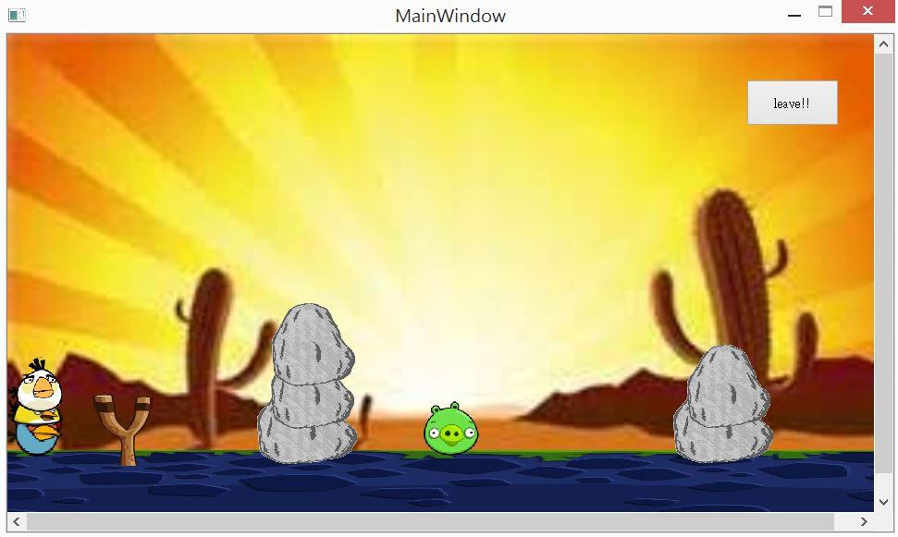

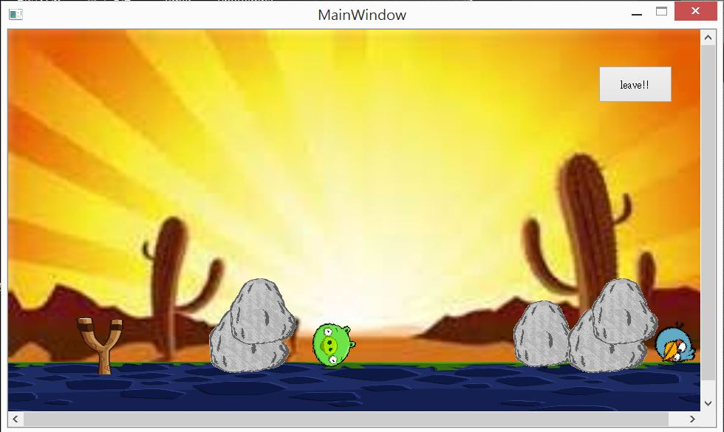

程式結構:

首先main 呼叫mainwindow出來後，視窗直接進入mainwindow中，城市中最主要有兩個物件，一是撞到會動像鳥一樣，一個是地板，撞到後被反彈，不同種類的鳥，繼承原本同一隻的性質，造成多型

如何操作呢?

點後就直接進入遊戲喔

拖曳滑鼠選擇要射擊的方向

按下s鍵還能有特殊功能喔

UML圖

|  |
| --- |
| **GameItem** |
| QSizeF g_size;  b2World *g_world;  static QSizeF g_worldsize, g_windowsize;  +b2Body *g_body;  +QGraphicsPixmapItem g_pixmap; |
| +void paint();  GameItem(b2World *world);  +~GameItem();  +static void setGlobalSize(QSizeF worldsize, QSizeF windowsize); |

|  |
| --- |
| **Bird** |
|  |
| +Bird(float x, float y, float radius, QTimer *timer, QPixmap pixmap, b2World *world, QGraphicsScene *scene);  +setLinearVelocity(b2Vec2 velocity);  +setTransform(const b2Vec2& position, float32  angle); |

|  |
| --- |
| **Yellow** |
|  |
| +Yellow(float x, float y, float radius, QTimer *timer, QPixmap pixmap, b2World *world, QGraphicsScene *scene);  + show(); |

|  |
| --- |
| **White** |
|  |
| +White(float x, float y, float radius, QTimer *timer, QPixmap pixmap, b2World *world, QGraphicsScene *scene);  +showt(); |

|  |
| --- |
| **GameItem** |
| QSizeF g_size;  b2World *g_world;  static QSizeF g_worldsize, g_windowsize;  +b2Body *g_body;  +QGraphicsPixmapItem g_pixmap; |
| +void paint();  GameItem(b2World *world);  +~GameItem();  +static void setGlobalSize(QSizeF worldsize, QSizeF windowsize); |

|  |
| --- |
| **Wood** |
|  |
| +Wood(float x, float y, float w,float h, QTimer *timer, QPixmap pixmap, b2World *world, QGraphicsScene *scene);  + setLinearVelocity(b2Vec2 velocity); |

|  |
| --- |
| **Land** |
|  |
| +Land(float x, float y, float w, float h, QPixmap pixmap, b2World *world, QGraphicsScene *scene); |

|  |
| --- |
| **Mainawindow** |
| +Bird *birdie;  +Bird *piggy;  +Bird *birdies;  +Bird *birdiee;  +Bird *birdiees;  +Bird *bomb;  +Bird *egg;  +Yellow *yellowbird;  +Yellow *yellowbirds;  +White *whitebird;  +White *whitebirds;  +QPushButton *m_button;  +int press;  +Int count;  +int x0;  +int y0;  +int k;  +int j;  +bool a  +bool b  +bool c  +bool d  Ui::MainWindow *ui;  -QGraphicsScene *scene;  -b2World *world;  -QList<GameItem *> itemList;  -QTimer timer; |
| -tick();  -QUITSLOT();  -handleButton();  -GetLinearVelocity();  - quitGame(); |